**Loop1:** sets the speed of the blinking light on the robot – there by default.

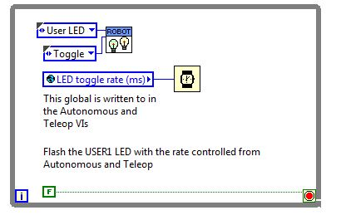

**Loop2:** determines the value of BallActionNew enumerator based on user inputs.

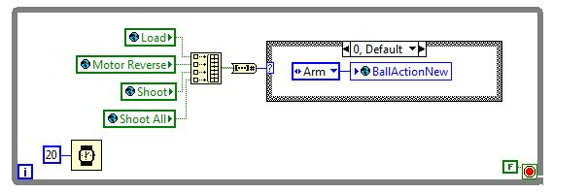

**Loop3:** extended encoder loop containing 4 of them – long story short, it sets up data collection from the encoders and allows the data to be sent to global variables.

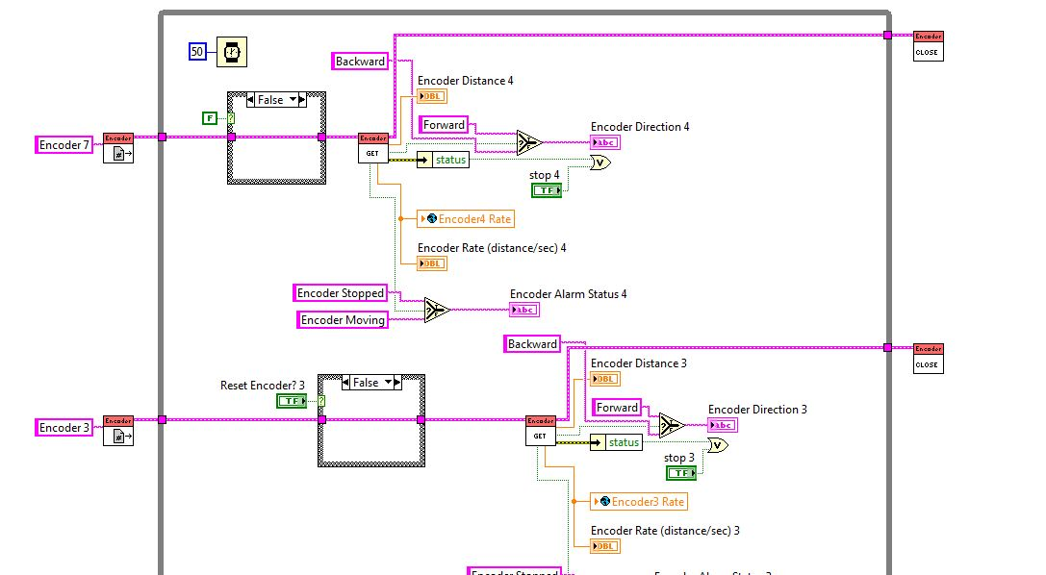

**Loop4:** moves the turret motor left and right based on buttons or joystick input.

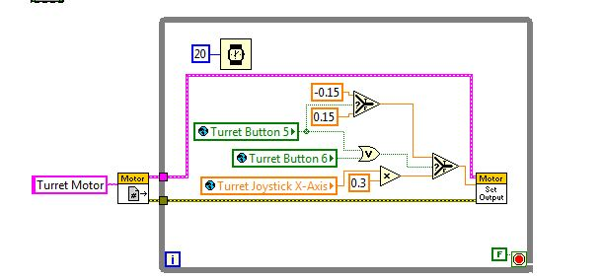

**Loop5:** allows the robot to move its bridge tip motor to change the orientation of the in-game bridge. It’s based on user input.

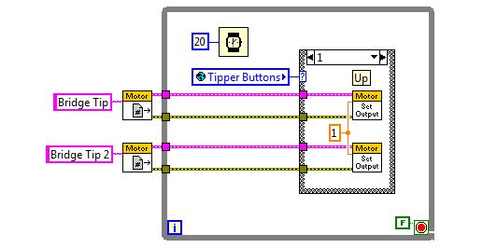

**Loop6:** checks the autonomous switch for the autonomous mode requested by the user.

